  ARTIFICIAL INTELLIGENCE  State space search | Abstract  State space search is the process of searching for a sequence of actions that take from an initial state to a goal state to formulate a solution for a given problem.  Iftekhar Mahmud Towhid  CSTE 4103: Artificial Intelligence

  - State space
In the theory of discrete dynamical systems, a state space is the set of values which a process can take. For example, a system in queuing theory recording the number of customers in a line would have state space {0, 1, 2, 3, ....}.
In games, the state space is the set of all possible configurations within the game which can be reached by legal actions. For instance, in chess, it consists of all the possible board configurations. Within this state space there is the subset of configurations which are valid according to the rules of chess.
A game's total state space is often readily calculated whereas finding the subset of valid configurations may be a considerable challenge. The size of a game's state space is related to its complexity. For some systems, the state space can be so huge that even for the fastest computer on earth, it make take thousands of years to explore all the states.

Here are the sizes of state space for some problems:
Problem | State space size
Theorem proving | Infinite
GO | 10¹⁷⁰
Chess | 10^{120c}
Checkers | 10⁴⁰
8-puzzle | 181,440

  - Problem solving by searching: State space search
- A wide range of AI problems can be formulated as searches.
- State space search is the process of searching for a sequence of actions that take from an initial state to a goal state to formulate a solution for a given problem.

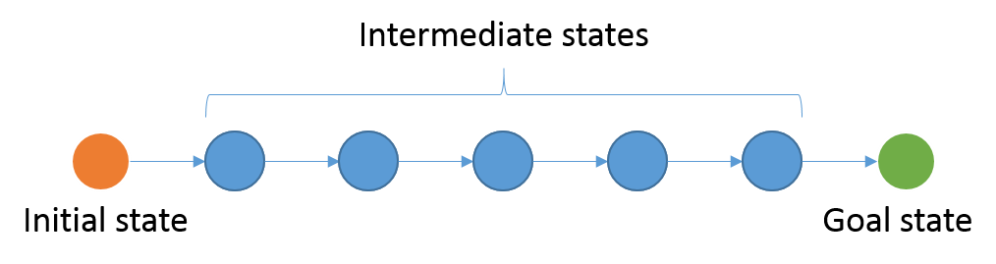
Figure: State space search

Search can be applied to many problems:
- Solution to a puzzle.
- Shortest path on a map.
- Proof of a theorem
- Sequence of moves to win a game
- Sequence of transformations to solve a symbolic integration problem
- Sequence of moves to achieve a desired state

State space search is an example of a weak method.
A weak method is:
- a problem-independent framework for solving problems
- It may have "stubs" for incorporating domain knowledge
However: weak methods usually cannot overcome the combinatorial explosion.
  - Formulating state space search
State space search can be applied for those systems which have a set of distinct states and the system can go from one state to another by applying an action/operator from a set of legal actions/operators. The search is started from a given initial state and run until a desired goal state is reached.
In summary, A problem is a tuple (S, s, A, ρ, G, P) where
- S is a set of states
- s ∈ S is the initial state
- A is a set of actions (sometimes called operators)
- ρ: S × A → S, is a partial function, that tells you for each state, which actions will take you to which states.
- G: S → bool, is the goal test function, which tells you whether a state is a goal state or not.
- P: S × (A × S)* → real, is the path cost function. A path is a sequence {s₀ a₁ s₁ a₂ ...a_{k} s_{k+1} } such that ∀i ∈ {1..k}, ρ(s_{i-1}, a_{i}) = s_{i}. Usually, but not always, this is the sum of the "step costs" assigned by a simpler step cost function (of type S × A × S → real).
As a frank explanation, a state space search is represented by:
- A set of states: the state space.
- An initial state.
- A set of operators/actions
- A set of goal states, or a single goal state
- An optional path cost function

The task is to find:
- a sequence of operators that leads from the initial state to a goal state

  - The search agent
An agent that tries to come up with a sequence of actions that will bring the environment into a desired state is called the search agent. Generally the search agent is a goal-based agent.

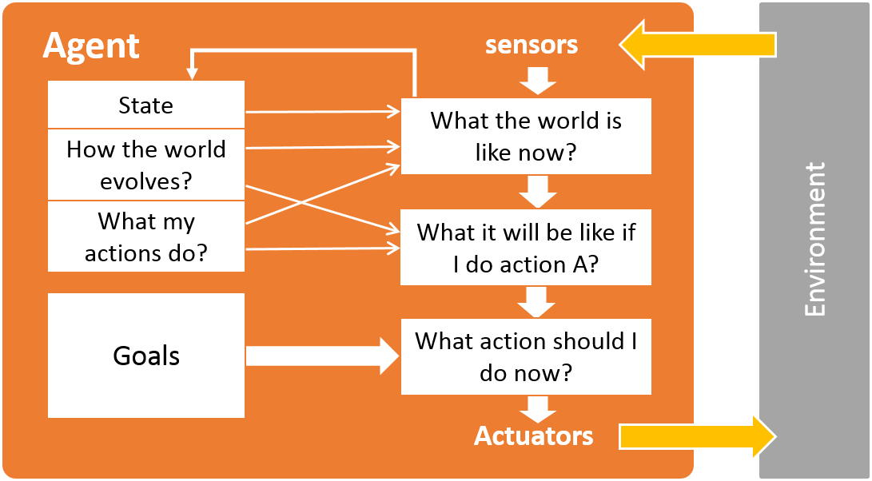
Figure: a goal-based agent

  - Some Classical search problems
    - The water-jug problem
Suppose you are given two jugs with no measuring marks, a 3-gallon one and a 4-gallon one. There is a pump to fill the jugs with water. How can you get exactly 2 gallons of water into the 4-gallon jug?

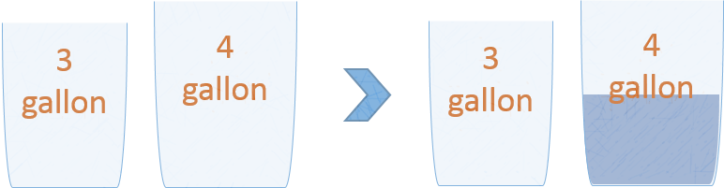
Figure: The water-jug problem

Formulating water-jug problem as a state space search problem:
State representation: We can represent the states as (m, n) where m and n represents the current amount of water in jug 1 and 2 respectively. m ∈ {0, 1, 2, 3} and n ∈ {0, 1, 2, 3, 4}.
Initial state: The initial state is (0, 0).
Goal state: The goal state is (x, 2), for x ∈ {0, 1, 2, 3}
Actions: There are three actions we can apply to any of the jugs: fill, empty and pour from one to another.
Path cost: No path cost function for this problem.

    - The 8 puzzle problem
The 8-puzzle is a square board with 9 positions, filled by 8 numbered tiles and one gap. At any point, a tile adjacent to the gap can be moved into the gap, creating a new gap position. In other words the gap can be swapped with an adjacent (horizontally and vertically) tile. The objective in the game is to begin with an arbitrary configuration of tiles, and move them so as to get the numbered tiles arranged in ascending order either running around the perimeter of the board or ordered from left to right, with 1 in the top left-hand position. An example scenario is shown below.
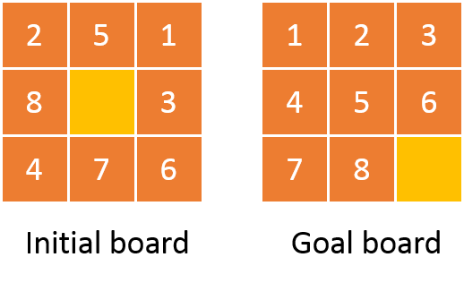
Figure: 8 puzzle problem
    - N Queen or 8 Queen problem
Place N queens in a N × N chessboard so that no queen can attack another.
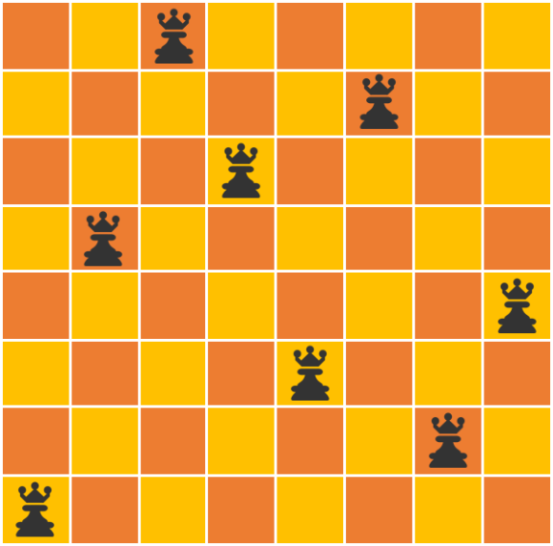
Figure: A 8 queen solution
    - Route finding problem
Find the quickest route from Arad to Bucharest.
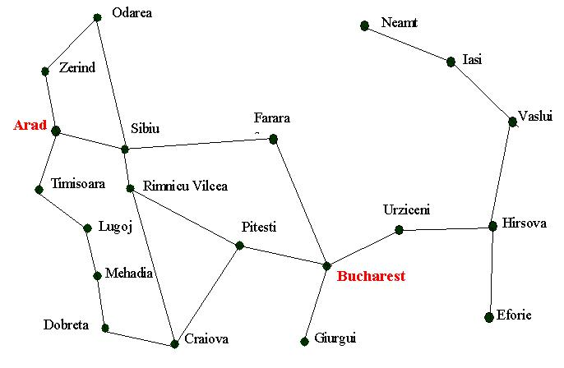
Figure: Route finding problem

    - More examples
- Puzzles: Rubik’s Cube, Towers of Hanoi etc.
- Detecting bugs in software and hardware.
- Solitaire games (FreeCell ...).
- Non-player-characters in computer games.
- Travelling Salesman Problem (TSP)
- Robot assembly sequencing: Planning of the assembly of complex objects.
- Attack planning: Finding a hack into a secured network. Used for regular security testing
- Query optimization in databases.
- Sequence alignment in Bioinformatics.
- And many more...

    - Toy Problems versus Real-world problems
Most of the problems we will work on will be toy problems:
- Puzzle-solving (8, 15-puzzle)
- 8-queens
- Cryptarithmetic
But in fact, these techniques are used to solve Real problems:
- Route-finding in airline travel planners
- Travelling Salesperson Problem
- VLSI layout (cell layout and channel routing)
- Automatic manufacturing (assembly sequencing)

  - Problem types
There are basically three types of search problems.
- Representation problems: Only need a representation of the system in a desired state, e.g. crossword puzzles.
- Goal finding problems: We only know the properties that a goal state should have, but we don't even know if any goal states exist. We just need to find a state that satisfies certain constraints for being a goal state. We don't care what action sequence gets us there. In these problems, optimality is concerned with the "best state". Examples: N-queens, integrated circuit layout and most other kinds of optimization problems.
- Action sequence finding problems: We know the state space in advance. We know which states are goals. We have to find the sequence of actions that get us to a goal state. In these problems, optimality is concerned with "cheapest path". Examples: mathematical theorems, Towers of Hanoi, 8 puzzle, water-jug problem and many other robotics problems.

  - State space representation
    - The state space graph
For a state space search problem:
- All the states the system can be in are represented as nodes of a graph.
- An action that can change the system from one state to another (e.g. a move in a game) is represented by an edge from one node to another.
- Edges may be unidirectional (e.g. Tic-Tac-Toe, chess, can't go back) or bi-directional (e.g. geographic move).
- It may be possible to reach the same state through many different paths.

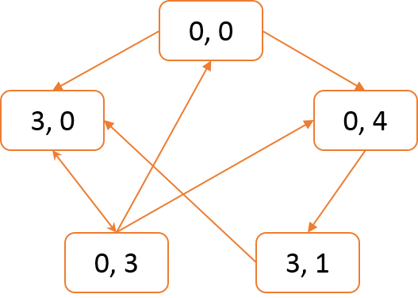
Figure: A partial view of the state space graph for the classical water-jug problem with jugs of sizes 3 and 4 gallon

    - The search tree
At any state, the search agent has to choose from a set of legal actions/operators which will take to a state which is likely on the path of the goal state. As often graphs contain cycles, the search agent can come back to a state it previously explored, and thus traversing the same path over and over again. For efficient searching, it is desirable that the search agent explores a node only once unless there is some need of backtracking. So, in general, the explored nodes in a state space graph constructs a spanning tree rather than a sub-graph.

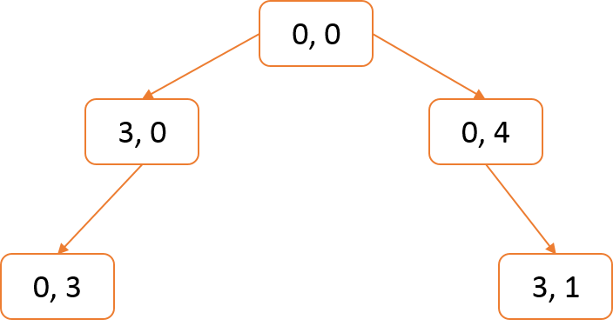
Figure: A partial view of the state space search tree the search agent actually explores for the classical water-jug problem with jugs of sizes 3 and 4 gallon

In the search tree:
- root node represents the initial state
- children of a node represents successor states
- fringe of the tree represents the states not yet expanded

  - Search strategy
    - Construction of the search tree
- The initial state is the root of the tree.
- For each un-expanded node in the tree, successors are generated. This is called node expanding. For the successors’ point of view it is called node exploration, i.e. the node is expanded and the successors are explored.
- The successors of a node is attached to the tree as the children of the node.
- We expand one node at a time. We have to decide which node to expand next from all the un-expanded nodes in the tree. How we make this decision is the essence of the search strategy.

    - A general searching algorithm
As we will see later there are a number of searching algorithms. Most of them work almost similarly. The criteria they mainly differ is how the nodes are organized in a data structure and how the search agent chooses the next node for expanding.

      - Data structure
As stated earlier, for most problems, though the state space is better represented by a graph, what the search agent actually does is better represented by a tree.
Thus, in case of implementation of a searching algorithm, we can use a tree data structure to keep track of the path the search agent explores during the search. For goal finding problems, a linked list will suffice as the data structure since we don’t have to keep the track of the path to the goal. For action sequence finding problems, we can use a modified linked list instead of a tree. In this case, each node should contain a pointer to its parent, so that after finding the goal state, we can backtrack to the initial node and record the trace, thus finding the action sequence in reverse order, which can be reversed to get the actual sequence.

At each iteration we have to choose among all the unexpanded nodes, the next node for expanding. The searching algorithm dictates which one to choose, but one important thing is to keep track of all unexpanded nodes. We can do this is two ways:
- We can use a single tree or linked list, each node should have an extra flag (we can name it checked flag) which marks if the node is expanded or not. At each iteration, we search through the tree or linked list for unexpanded nodes and ignore all the nodes whose checked flag is set.
- Alternatively we can use two linked list instead of one. In many literatures, one is called the OPEN list and the other is CLOSED list. Each explored node is put in the OPEN list. After we expand a node and explore its successors, we pop it from the OPEN list and put it in the CLOSED list. Thus at each iteration we only have to find in the OPEN list to choose the next node for expanding.

After we explore a successor of a node, before putting it into the tree or linked list, we have to search through the tree or list to see if it is already explored. In case we have OPEN and CLOSE lists, we have to search in both the lists.

      - The searching algorithm
The following are the two general algorithms for Goal Finding problems. Algorithm 1 uses a single linked list and Algorithm 2 uses two linked lists.
Algorithm 1:
Given a state space graph G, an initial state S_{i}, a goal state S_{g}
PROCEDURE Search (G, S_{i}, S_{g})
- INITIALIZE:
L: Linked List ⇒ {}
S_{c}: Node ⇒ NULL
GOAL_FOUND: Boolean ⇒ FALSE
GOAL_EXISTS: Boolean ⇒ TRUE
- Add node S_{i} to L
- WHILE GOAL_FOUND IS FALSE AND GOAL_EXISTS IS TRUE DO
SET S_{c}:- An unexpanded node from L //How to choose?
IF S_{c} IS NOT NULL THEN //There are unexpanded nodes
in the list
FOREACH successor node S_{s} of S_{c} DO
IF S_{s} EQUALS S_{g} THEN
SET GOAL_FOUND := TRUE
ELSE
IF L not contains S_{s} THEN
Add S_{s} to L //Which order?
END IF
END IF
Mark S_{c} as expanded
END FOREACH
ELSE
SET GOAL_EXISTS := FALSE
END IF
END WHILE

Algorithm 2:
Given a state space graph G, an initial state S_{i}, a goal state S_{g}
PROCEDURE Search (G, S_{i}, S_{g})
- INITIALIZE:
OPEN : Linked List ⇒ {} //OPEN list
CLOSED : Linked List ⇒ {} //CLOSED list
S_{c}: Node ⇒ NULL
GOAL_FOUND: Boolean ⇒ FALSE
GOAL_EXISTS: Boolean ⇒ TRUE
- Add node S_{i} to OPEN
- WHILE GOAL_FOUND IS FALSE AND GOAL_EXISTS IS TRUE DO
SET S_{c}:- An unexpanded node from OPEN //How to choose?
IF S_{c} IS NOT NULL THEN //There are unexpanded nodes
in the list
IF S_{c} EQUALS S_{g} THEN
SET GOAL_FOUND := TRUE
ELSE
FOREACH successor node S_{s} of S_{c} DO
IF OPEN and CLOSED not contains S_{s} THEN
Add S_{s} to OPEN //Which order?
END IF
Move S_{c} to CLOSED.
END FOREACH
END IF
ELSE
SET GOAL_EXISTS := FALSE
END IF
END WHILE

      - The three challenges
From the above general searching algorithms we see three challenges:
- How to generate the successors?
- In which order should we insert newly explored successor into the list?
- Which node should we choose to expand next from the list?

How to generate the successors?
How we generate the successors of a node depends on the problem itself. In the problem space, we have a set of operators, but we may apply only a subset of them at any given state. The data structure which represents a state should be able to apply these operators on itself.

In which order should we insert newly explored successor into the list?
This depends on the searching algorithm we are using. Some algorithms insert the successors at the end of the list and some insert at the front and some may insert according to some priority. We will learn this in details later.

Which node should we choose to expand next from the list?
This depends both on the type of problem and the searching algorithm. We consider two things:
  - Do we have the state space graph in advance or do we know nothing about the state space?
  - Is there any criteria which gives us the information that ‘this’ node is better than ‘that’ node, i.e. there are better chances of ‘this’ node than ‘that’ node of being in the path of goal state.
If we do not know the state space in advance and we do not have any means to measure betterness of a node, the searching algorithm can choose any of the nodes, either from the front of the list or from the end.
Sometimes if the state space graph is given then it may contain the information about which node is closer to the goal node. Thus, if there are some means to measure betterness of a node, the algorithm may choose the best node at each iteration.

    - Algorithm evaluation
We evaluate the searching algorithms depending on four criteria:
- Completeness: Are they guaranteed to find a solution?
- Time complexity: How long do they take in search time?
- Space complexity: Storage required
- Optimality: When there are several solutions, does it find the best one?

Time and space complexity are measured in terms of:
- b: maximum branching factor of the search tree
- d: depth of the least-cost solution
- m: maximum depth of the state space (maybe ∞)

  - Recommended reading
http://cs.lmu.edu/~ray/notes/problemsolving/

